Preparing a Linux Ubuntu 20 OS for Bootcamp

Part01 NodeJS & NPM

1. Open a terminal window to run the following commands
2. Update your linux box:  
   sudo apt update  
    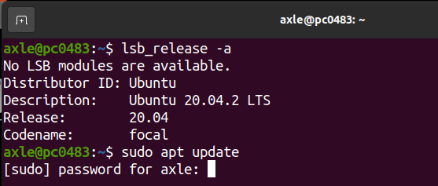
3. This is the command to install NodeJS after the update  
   sudo apt install nodejs
4. Install npm once Node is done

sudo apt install npm

1. (Optional) Check for the versions by running the following commands:  
   nodejs -v and

npm -v

Part02 MongoDB

1. (Optional) If you do not have cURL install, please install it in order to install the community version of MongoDB  
   sudo apt install curl

### Use cURL to import a public key used by npm (you may also use Wget)

wget -qO - https://www.mongodb.org/static/pgp/server-4.4.asc | sudo apt-key add -

### Create a list file for Ubuntu in a special folder in the apt directory echo "deb [ arch=amd64,arm64 ] https://repo.mongodb.org/apt/ubuntu focal/mongodb-org/4.4 multiverse" | sudo tee /etc/apt/sources.list.d/mongodb-org-4.4.list

1. Do another update, follow the command in #2 above
2. Now install the latest version of MongoDB

sudo apt-get install -y mongodb-org

1. For the community version, you will need to start the service manually  
   sudo systemctl start mongod
2. Check the status of the MongoDB service  
   sudo systemctl status mongod

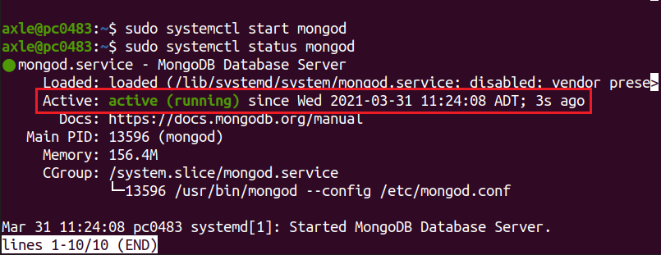

Part03 Visual Studio Code

1. Finally install Visual Studio code using *snap*. If Snaps is not installed on your machine, the following command will install it first then VS Code, its automatic

sudo snap install --classic code

Part04 (Optional) Postman

1. If you need Postman to test REST calls, install it using this command

sudo snap install postman

Part05 (Optional) CORS Plugin in Mozilla Firefox Web Browser

1. If you need a Cors plugin, go to **Add-ons** in Firefox.

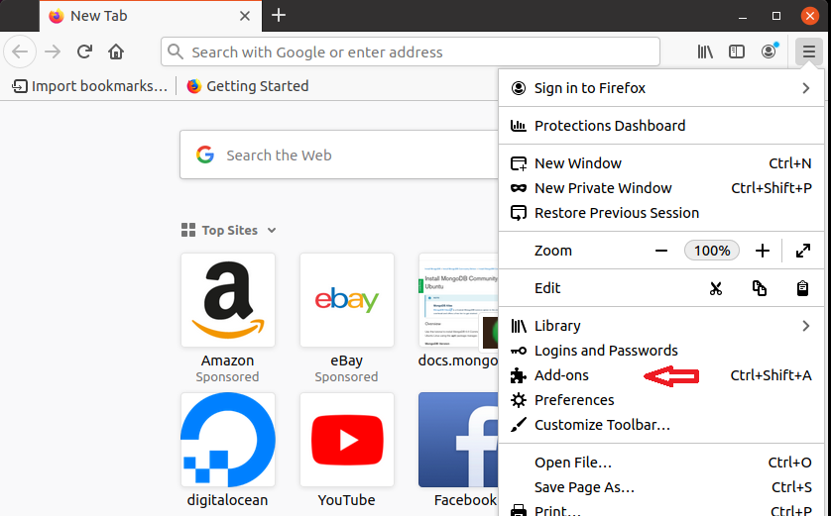

1. On the next window, find the search bar and type in *cors*  
     
   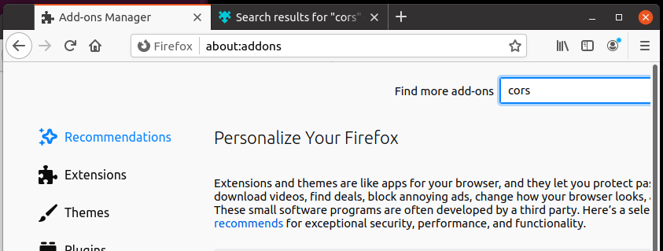
2. A new tab or window will open. The one I am using is CORS Everywhere, just click on the icon  
     
   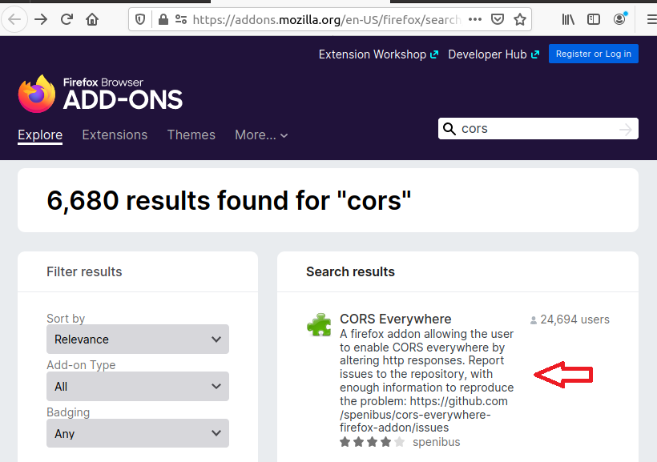
3. After clicking on CORS Everywhere, a new window/tab will open, click on *Add to Firefox*  
   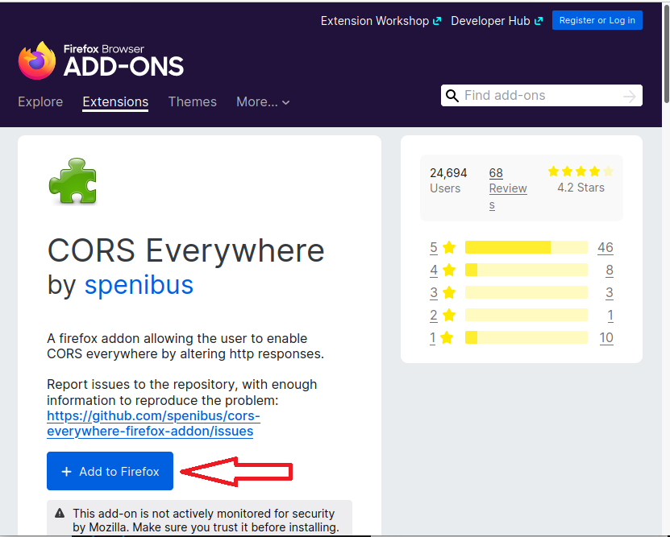
4. You will get a message to confirm the plugin, click on *Add*  
     
   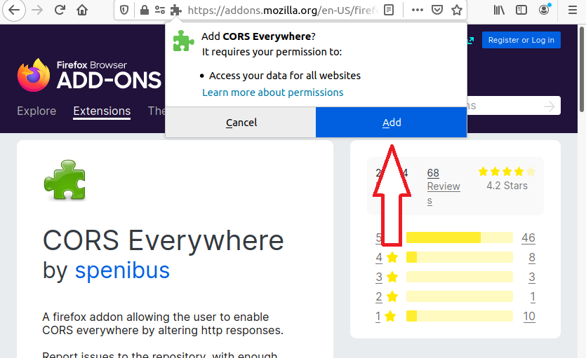
5. You will then get a message, click *Okay Got It*

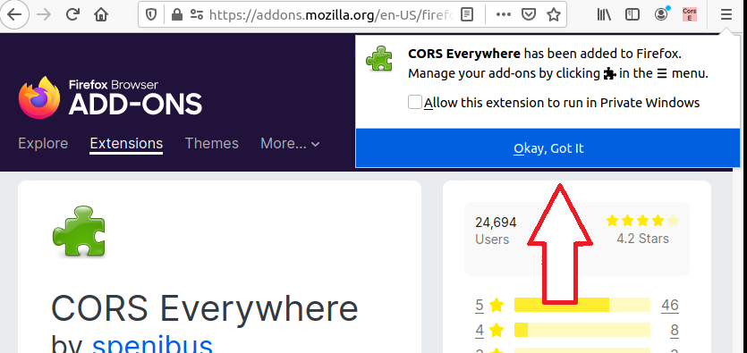

1. The plugin will appear as a very small icon at the top of you browser interface, if it appears pink/orange, then it is NOT on. To turn it on, click on it, it will change to green, meaning on.  
     
   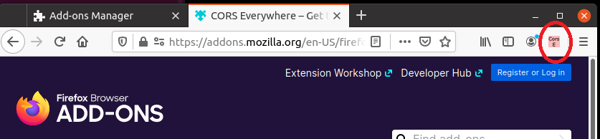

Appendix

Configuring Postman

1. You do not have to create an account if prompted to do so. There is a small grey line at the very bottom which says: *Skip signing in and take me straight to the app*. You can choose this option.
2. On the next window, you can close the Launchpad tab.
3. Just click on the + icon which will open a new window with the default GET request setup.
4. To make a GET request to an app on your local machine, just enter the address and click the Send button:  
   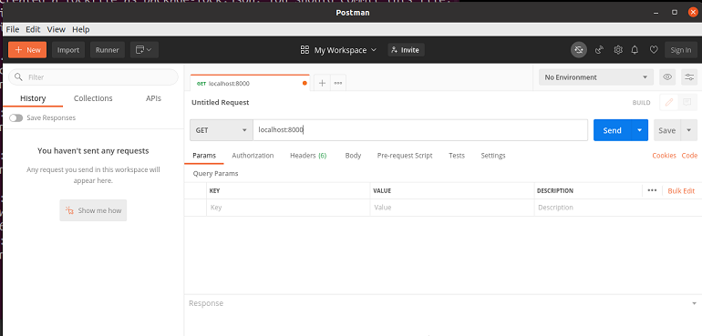
5. Here is the result of one api call:  
   